CO2 ASSESSMENT TOOL 3 DEBUGGING & OPTIMISATION TASK
Name: Lavanya
Reg No: 192521271
Course Name: Design And Analysis of lgorithms
Course code: CSA0613
Debugging Linear Search Code
Aim
To debug the given Linear Search program, correct the search logic, improve readability, and analyze its time complexity.
Problem Statement
The given Linear Search implementation contains incorrect control flow because the return statement is misplaced. This can produce misleading results when searching for an element that is absent. The program must be corrected so that it properly reports whether the target element is found or not.
Given Correct Code
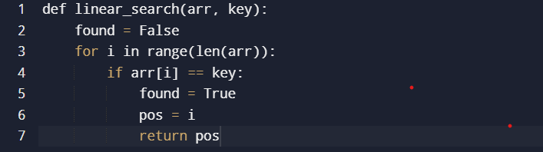
Errors Identified
- The variable found is never used after being assigned.
- The function does not return any value when the element is not found.
- The missing return statement causes the function to return None.
- The code is difficult to maintain because unnecessary variables are used.

Corrected Source Code
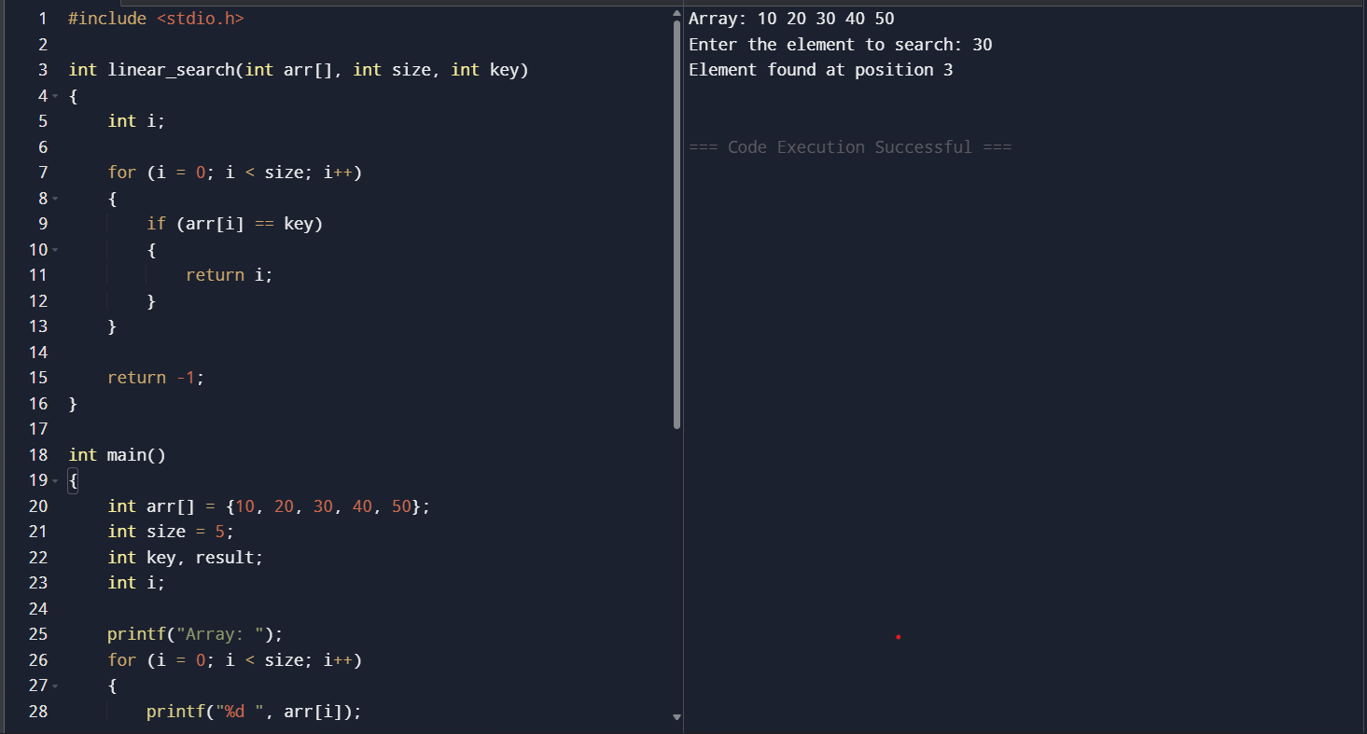
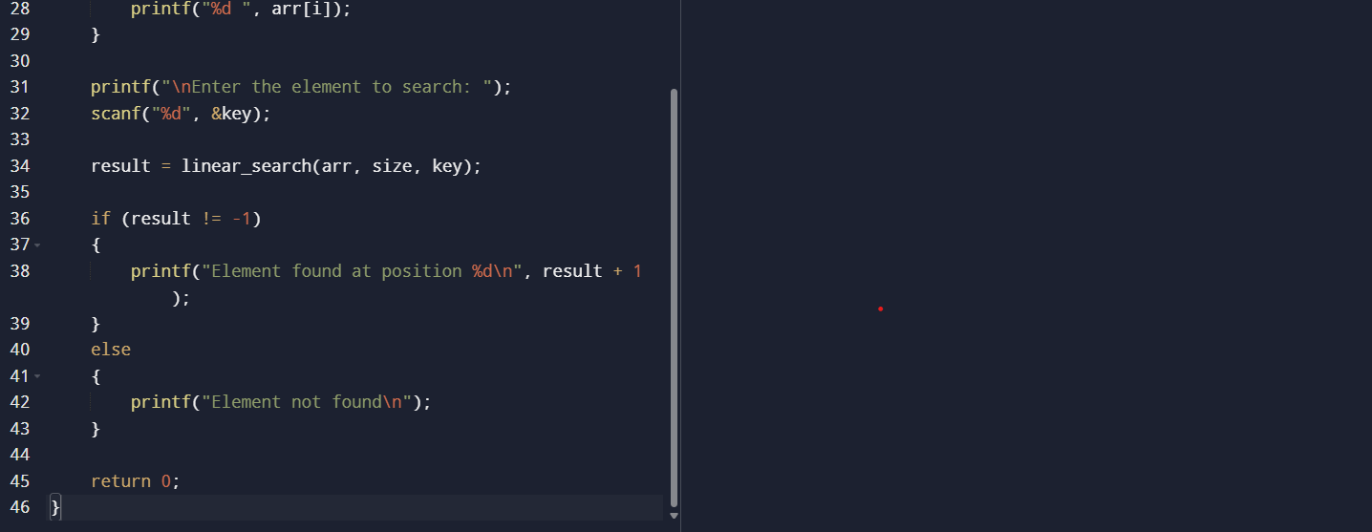

Time Complexity Analysis
Case | Complexity
Best Case | O(1)
Average Case | O(n)
Worst Case | O(n)
Explanation
- Best Case: The element is found at the first position.
- Average Case: The element is found somewhere in the middle.
- Worst Case: The element is at the last position or not present.

Documentation
- Programming Language: Python
- Algorithm Used: Linear Search
- Input: List of integers and search key
- Output: Position of the element if found; otherwise displays "Element not found."

Conclusion
- The corrected program properly handles both successful and unsuccessful searches. Returning -1 when the element is absent improves readability and avoids misleading results. The algorithm is simple and efficient for searching small or unsorted datasets.

